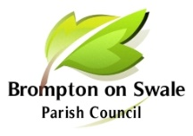

Brompton-on-Swale Parish Council
Clerk: Martin Reynolds
31 St Pauls Drive Brompton on Swale, Richmond DL10 7JP

Tel: 07849 048581

email: bosparishclerk@hotmail.com
www.brompton-on-swale.org.uk

Annual Parish Meeting
Thursday 19 May 2022

NOTCIE THAT THE ANNUAL PARISH MEETING OF THE PARISH COUNCIL
WILL BE HELD ON THURSDAY 19 MAY AT 7.00 PM
AT THE BROMPTON-ON-SWALE COMMUNITY SPORTS HALL, HONEY POT ROAD, BROMPTON-ON-SWALE

AGENDA

1 To receive apologies and approve reasons for absence

2 To confirm the Minutes of last meeting held on 6 May 2021 as a true and correct record

3 Matters arising – to receive any information on ongoing matters from the minutes and decide on further action where necessary

4 To receive the Annual Report from the Chairman (previously circulated)

5 To receive and note issues raised by members of the public

